Everyday Health Emotional Health

New Netflix Series Explores Humans’ Bond With ‘Dogs’

Documentary looks at canine companionship, which studies show can foster emotional and physical well-being.

By Sue Treiman
The Netflix documentary "Dogs" premieres on Friday, November 16, 2018.
Photos Courtesy of Netflix
November 15, 2018
Man’s best friend can be man’s best medicine. Dogs, a new Netflix documentary series debuting Friday, November 16, explores the bond between canines and humans. From the family Fido to therapy animals and trained service dogs, researchers say the love and support these companions provide can have very real health benefits.
“No species on the planet — not even humans — are as overflowing with unconditional love as dogs,” says Glenn Zipper, coproducer and series originator with Amy Berg. “Medicine and doctors aside, I think we can all agree there is no greater healing power than love.”
The six-part Netflix documentary tells the stories of six dogs and their caregivers around the world, in locales such as Syria, Germany, Italy, and the United States.
“Dogs don’t just make us feel loved,” Zipper says. “Dogs make us feel safe.”

Studies Point to Specific Health Benefits
There is also evidence that the companionship of dogs and other pets can have quantifiable physiologic effects.
According to research published in May 2015 in the journal Complementary Therapies in Clinical Practice:
- Pets “enhance the quality of life of patients especially regarding aging, cardiovascular diseases, and overall sense of wellness.”
- Pet owners who have a heart attack have a five-fold increase in one-year survival.
- The mere act of petting is associated with the release of feel-good chemicals produced by the body, such as serotonin and dopamine.
“Pets improve well-being, increase longevity, and heighten compliance with medical treatment,” says Edward T Creagan, MD, lead author of the study, professor of medical oncology at the Mayo Clinic in Rochester, Minnesota, and an expert on animal-assisted health.
In a 2013 scientific statement, the American Heart Association highlighted evidence that suggested pet ownership, particularly having a dog, is associated with decreased risk of cardiovascular disease.
According to the statement, many studies have found that pet owners in general have lower blood pressure, and dog owners engage in more physical activity.
Alan Beck, ScD, animal ecology professor and director of the Center for the Human-Animal Bond at Purdue University in West Lafayette, Indiana, believes that this beneficial bond between man and dog is rooted in evolution.
RELATED: Playing With a Dog Helps You Feel Less Stressed
“If you really think about it, when early humans started finding and feeding wolves, they did it for companionship,” says Dr. Beck. “We always had a nurturing orientation, and we looked for emotional connection, which we continue in our dogs.”
Everyday Health recently spoke with three people whose lives have been changed and enriched by dogs. None of them were involved in the making of the Netflix series.

A Special Bond Forged in the Shadow of Combat
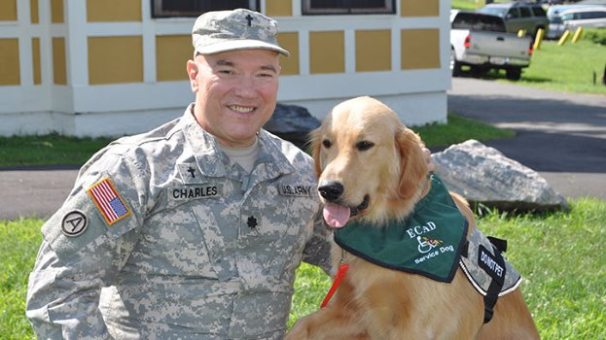
Retired Army Lt. Col. John Anthony Charles and his dog Dozer.
Photo courtesy of John Anthony Charles
Retired Army Lt. Col. John Anthony Charles, 65, of West Hartford, Connecticut, is a former chaplain who returned from Bosnia and Kuwait with traumatic brain injuries and post-traumatic stress disorder (PTSD).
His unsteady gate, double vision, and unpredictable panic attacks made everyday life precarious.
Charles enrolled in the Educated Canines Assisting with Disabilities program (also known as East Coast Assistance Dogs, or ECAD). There, he says, things began to improve dramatically when one of the trained service dogs “chose him.”
“We were at the ECAD ‘graduation,’ meeting the trained dogs, when one pup came directly up to me, rested his head on my lap, and decided he was mine,” says Charles. That was Dozer.
Dozer’s rigorous two-year training program cultivated the extreme self-control, discipline, loyalty, and commitment demanded of a service animal. But it was ultimately Dozer’s heroism that won Charles’ heart.
The first incident occurred not far from home, on a busy street. Suddenly dizzy and disoriented, Charles briefly lost his bearing and stumbled directly into the path of a fast-moving car.
“Dozer came up and pushed me out of the way, just as a car rushed past me,” he recalls.
Dozer repeated the life-saving feat on a second occasion, when another vehicle careened within inches of Charles’ unsteady body. Charles says he never ventures far from his beloved companion.
“Since the fifth day of ECAD training, when Dozer woke me from a nightmare with a chest pump, turned on the lights, and opened the door to ease my anxiety, we have been forever bonded,” says Charles. “But these events were unforgettable.”

Sensing Disaster and Saving a Life
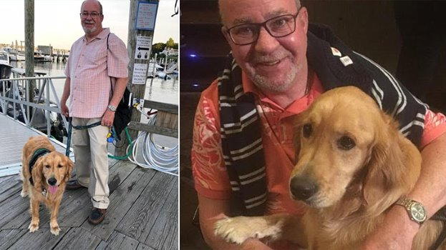
Tom Griffen's service dog Sterling saved his life.
Photos courtesy of Tom Griffen
Former schoolteacher Tom Griffen, 60, of Fairfield, Connecticut, was similarly rescued by his canine companion.
Griffen is an avid camper who cherished solo glamping trips. But living with type 1 diabetes, multiple sclerosis, and early-stage lung cancer had made him fearful of being far from medical care.
When he was paired with Sterling, a service dog capable of responding to more than 80 commands, Griffen regained the confidence to venture into the wilderness again. He knew that Sterling would awaken him if his insulin pump ever sounded a failure alarm.
Ironically, when a true emergency occurred, the alarm never rang. But Sterling sprang into action anyway. Sterling had never been trained to sniff out changes in blood sugar levels, as some diabetes dogs are. But he sensed impending disaster.
“It was during the night, and he jumped on me, and woke me from a sound sleep,” says Griffen. “Once he knew I was awake, he brought me the bag with all my blood testing paraphernalia. Then he opened the fridge by tugging on the attached rope, and brought me a bottle of orange juice. I was astounded, to say the least.”
“If he hadn’t acted as he did, I don’t think I would be here now,” says Griffen.

A Loyal Friend in Good Times and Bad
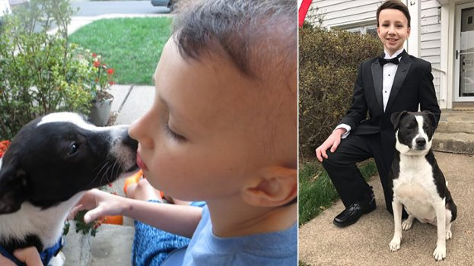
Jimmy Alverson's dog Molly has seen him through brain cancer treatments and recovery.
Photos courtesy of Jimmy Alverson
Of course, dogs need no special training to provide the kind of friendship and warmth that Jimmy Alverson sought when, at age 13, he was recovering from brain cancer. After a lengthy, debilitating treatment, the Make a Wish Foundation invited the suburban Washington, DC, teen to ask for something special.
“I know most kids ask for a trip, but that only lasts a day. I wanted something that would be around for a long time,” says Alverson, who’s now 15 years old. “I wanted a dog.”
Months after his new companion Molly arrived, Alverson suffered a serious medical setback that again isolated him from school and friends for months. This time, Molly made the separation bearable.
“She’s not like a friend who pulls away or leaves when things get difficult. She’s always there, in good times and bad. Just knowing that, I never have to doubt her,” says Alverson, who is now cancer-free.
Alverson’s mother Susan remarks on how sensitive Molly is to the family’s moods and needs. “Molly can sense when any of us are feeling sad or anxious or upset,” she says. “She is empathetic and calm. She just remains still and allows people to be quiet. We love her.”

